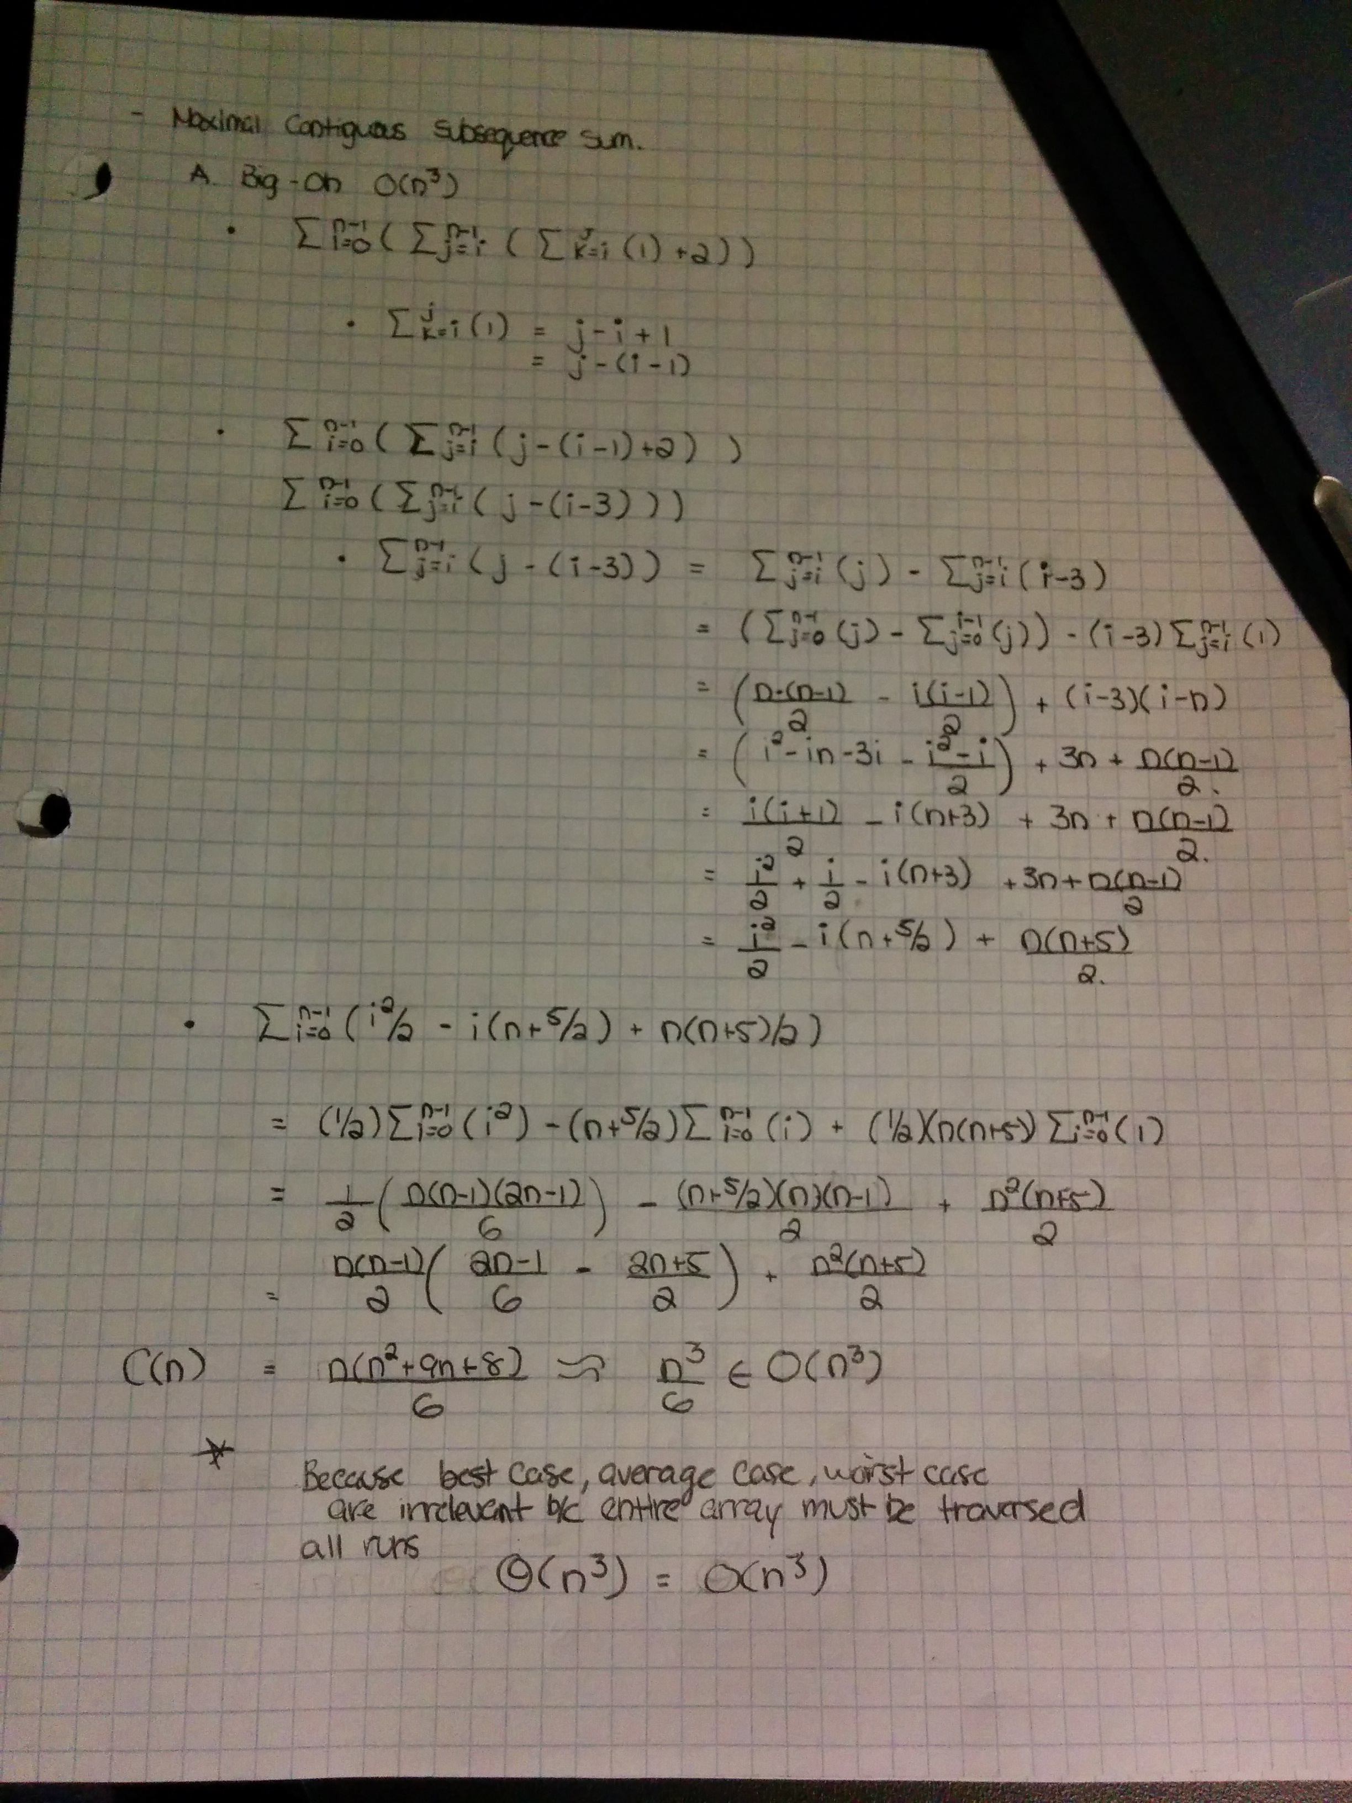

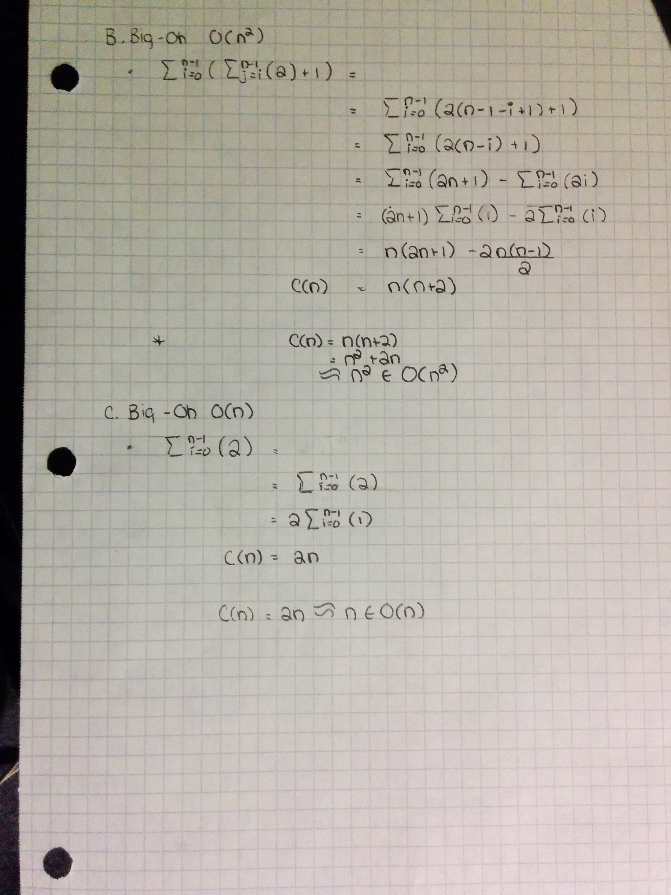

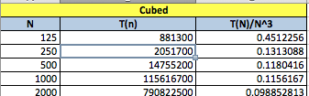

* Because the function is of O(n^3), T(n) = c (n^3).
* 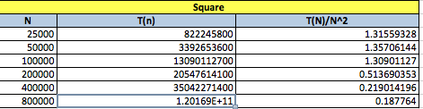Based on the data aquired, we use the empirical data point T(n) = 790822500ns when n = 2000 to find that the constant c = T(n)/n^3 = 0.0988.
* The value of C is converging to a positive and tiny value, meaning our function is more like O(n) than O(n^2)

